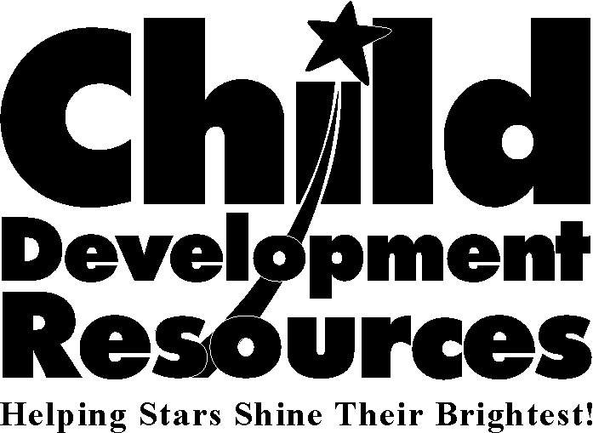
JOB DESCRIPTION

TODDLER Teacher AIDE

Under the supervision of the toddler teacher, the toddler teacher aide shall be responsible to:
1. Support the toddler teacher in carrying out goals, policies, and activities designed to implement school readiness goals and meet Head Start/Early Head Start Performance Standards and Child Care Licensing Requirements.
2. Assist with classroom activities and supervision of children, including in the outdoor play environment.
3. In cooperation with other staff, assist with housekeeping, safety routines and drills, class preparation, and organization of the learning environment.
4. Assist the toddler teacher in implementing daily and weekly lesson plan activities.
6. Assist in care-giving routines.
7. Maintain positive relationships and effective communication with children, parents, and staff.
8. Attend staff meetings and in-service training as required.
9. Participate in recruitment efforts as needed.
10. Contribute to a healthy and successful nutrition program by eating center-prepared meals with the children.
11. Other duties as assigned.

EMPLOYMENT STANDARDS
Required Education and Experience:
- High school graduate or equivalent.
- Minimum of six (6) months of verifiable paid or volunteer work experience in a preschool or licensed infant care center.
- Minimum of six (6) completed units in child/human growth or early childhood child development. (All course work must be completed with a grade C or better to receive credit).

Preferred Criteria: Bilingual English/Spanish skills. Completed units in child/human growth & development, child/family & community, and/or infant/toddler care. Experience with infants and/or toddlers in a group setting.
Knowledge and Abilities: Ability to read, write, and speak the English language fluently. Sensitivity to needs of low-income families and to multicultural beliefs and practices. Ability to work with high-risk families. Ability to be flexible and work as a cooperative team member. Ability to maintain strict confidentiality.

Physical Abilities: Ability to see at normal distance and hear normal conversations and sounds. Use hands and fingers to fill out required forms on regular and NCR paper. Ability to sit on the floor, bend at the waist, kneel and/or stoop down 75% of the time. Ability to safely lift or assist children weighing up to thirty-five (35) pounds.

License or Other Requirements. Must hold Infant First Aid and CPR certificate and renew upon expiration. Must submit to a job-pertinent agency-paid pre-employment physical examination, negative tuberculosis test, and criminal record background checks. Employment is conditional pending satisfactory results of all required tests and background checks. Periodic physical examinations and TB clearances will be required if hired. Mandated Reporter.

